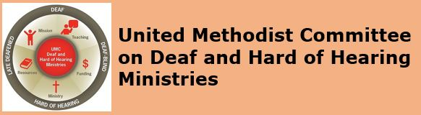
[Image Description: United Methodist Committee on Deaf & Hard of Hearing Ministries and its logo]
Monthly E-News - AUGUST 2019

ADVOCACY: Deafblind-related Observance in August
The American Academy of Ophthalmology recognizes August as Cataract Awareness Month. Some organizations observe Cataract Awareness Month in June, while others observe it in August. For D/deaf and hearing people alike, cataracts can be an eye condition that impacts daily living overtime. For some people, this type of vision loss causes short-term to long-term problems. In fact, most Deaf and hard of hearing people rely heavily on their sight and losing any vision can be distressing. It’s reported that approximately 24.5 million Americans, have cataracts, which affects more than half of all Americans by age 80. The National Eye Institute defines low vision as a visual impairment that interferes with the ability to perform activities of daily living, in which glasses, contact lenses, or medication does not correct the vision loss.

When it comes to cataracts, there is a general clouding of the vision. As the whole eye lens is affected, the blurring of the vision may or will worsen over time. While cataract surgery is commonly done, many seniors live with cataracts for months or even years before surgery is done. If left untreated, it can lead to permanent blindness. Annual eye exams are a good way to detect the onset of cataracts.
WAYS TO OBSERVE IT
Some risk factors include, but are
not limited, are:
- Smoking
- Family history
- Diabetes
Being proactive and speaking with your eye doctor is always best.

WAYS TO OBSERVE IT
A few ways to observe Cataract Awareness Month:
* Publish a newsletter article
* Plan a panel discussion
* Include a bulletin insert
* Share it during announcements
* Invite a guest speaker

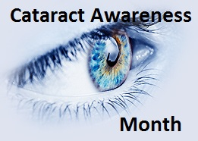
[Image Description: An eye and eye lashes with the words Cataract Awareness Month.]
Deaf Ministry Spotlight
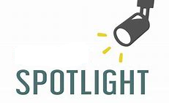
[Image Description: a spotlight shining on the word SPOTLIGHT.]

This month’s ministry spotlight is Frazer Memorial United Methodist Church, a hearing church Montgomery, AL. This new ministry has an interpreting ministry with a coordinator to support its accessibility throughout the life of the church. Part of the church’s commitment to accessibility is offering a sign language interpreter during one of its several worship services, both traditional and contemporary; moreover, an interpreter will be provided based on the service time that is requested. One highlight is the church supported a sign language interpreting student through the offering of the Joan Mathison Scholarship Award. Along with this, the church supports accessibility through the building of wheelchair ramps in its local community. In addition, Frazer is involved in Deaf missions and has been working with the Deaf community in Haiti since 2011. They have partnered with The Hands and Feet Project (working with an orphanage).

[Image Description: An image of the church name Frazer with the word church spelled vertically.]
* Highlight your Deaf ministry with us by emailing Rev. Yates at leoyjr@gmail.com.

Interpreting Ministry Best Practice

This edition’s interpreting ministry best practice is having or keeping a list of one or more substitutes (a backup) for when the primary interpreter is unavailable. Some interpreters have or know some colleagues from the interpreting community to help out when they need to miss a Sunday, while some churches will reach out to an agency to reserve an interpreter. Interestingly, some church interpreters train or mentor new interpreters from their faith community as a way of providing substitute relief. Understandably, there are interpreters who feel it is the church’s responsibility to find a replacement, while others assume the responsibility to find a substitute since they are more resourceful and knowledgeable about where to locate interpreters. Regardless of who recruits the substitute, if an interpreter is unable to be at the service, then those who primarily utilize the interpreter should be made aware (e.g. send a text or email beforehand, announce it in the bulletin and/or weekly e-news). Some parishioners may still wish to come though there is no interpreter available, which is possible if the Deaf or hard of hearing parishioner has relationships with other church members or their children are actively involved in children’s ministries. If this is the case, then the church can consider providing captioning and worship materials as an alternate accommodation, but first check with the parishioners who utilize interpreting services. It’s always recommended that the church budget for interpreters (keep a line item in the budget) to cover for substitute interpreters, even if the primary interpreter never charges the church for his or her services.

A few ways to recruit a freelance interpreter include: a search through The Registry of Interpreters for the Deaf (RID) – search freelance interpreters by state, try searching through the state chapter of RID, checking with the state Vocational Rehabilitation office for suggested list of interpreters, and exploring a possible nearby college or university interpreting education programs (for a student interpreter). Like with most church positions, planning ahead of time for coverage is always best. Certainly, making arrangements through an agency is the simplest or fastest way, but is typically the more expensive route (search for agencies in your state here).

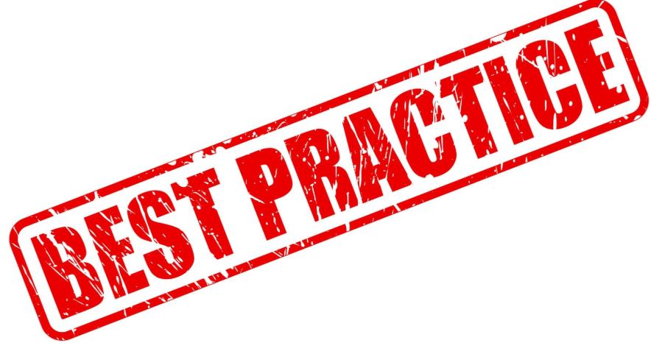
[Image Description: The words “Best Practice” stamped on a piece of paper.]

New Deaf Ministry Resource Book
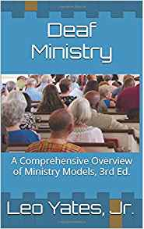
[Image Description: Book cover is blue and has an image of a sanctuary with parishioners and the book title Deaf Ministry by Leo Yates, Jr.]

A new Deaf Ministry resource is the book, Deaf Ministry: A Comprehensive Overview of Ministry Models, 3rd Ed. (2019). The book offers a comprehensive overview of the various Deaf ministry models available for churches and ministries who wish to be in ministry with Deaf, hard of hearing, late-deafened, and Deafblind persons and their families. The 3rd edition includes many resources and several appendices to support new and innovative ministries, such as planning: a sign language class, an ASL Day event guide, and a peer support group for people who struggle with losing their hearing. It also includes ways to implement and promote the church’s ministry. A helpful resource, the book can be shared with church leadership about beginning Deaf ministry, for sharing with other churches who may be exploring the idea of beginning a Deaf ministry, to be reviewed by Deaf ministry (or disability ministries) committees for expanding its ministry, and/or for sharing with newcomers to a Deaf ministry committee. The book is available in paperback and as an e-book on tablets by going to Amazon.com.

Deaf Ministry Support for Churches

The Deaf and Hard of Hearing Ministries Committee (of Global Ministries) is available to provide support and consultation for churches considering starting a Deaf ministry. Consultation can include how to implement a Deaf ministry, how to promote a Deaf ministry, brainstorm ideas for expanding the ministry, how to have a Deaf-friendly worship service, what resources are available, to discuss available grants and other funding sources, and among other needs. Each consultation includes receiving a church resource guide. Consultation is provided by Rev. Yates and/or one of our committee members. Contact the Rev. Leo Yates, Jr. at leoyjr@gmail.com.


[Image Description: A blue background with a person writing a plan with background images like email, a calculator, & a clock.]

Upcoming Deaf Ministry Boot Camp in GA

Mount Pisgah UMC in Johns Creek, GA is hosting a Deaf Ministry Boot Camp on September 21, 2019 from 10am to 2pm. This exciting and interactive workshop will be presented by the Committee on Deaf & Hard of Hearing Ministries. Registration is free, but participants are required to RSVP (to plan for lunch). Participants will learn some basic sign phrases, ministry ideas, how to improve communication access, suggestions for how to begin a Deaf ministry, and more. Click here to learn more about the workshop and to register for the event. Contact the Rev. Leo Yates, Jr. at leoyjr@gmail.com if you have specific questions about the workshop. Email reasonable accommodation requests by September 7th to Stephen Taylor at staylor@sns360.org.

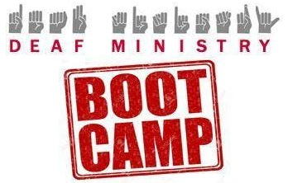
[Image Description: Deaf Ministry is displayed in English and the manual alphabet with the stamp Boot Camp.]

Accessibility Ideas
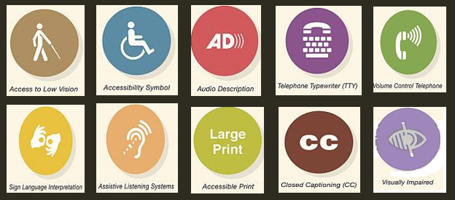
[Image Description: 10 disability symbols, such as low vision, captioning, large print, and audio description.]

This edition’s accessibility idea for deaf and hard of hearing people is the use of handouts. There are MANY more hard of hearing and late-deafened people who do not use sign language as their primary way of communicating, but who rely on lip reading and/or hearing aids or cochlear implants . For many who have hearing aids or cochlear implants, spoken and written language are their typical modes of communication. For some, they will be comfortable with receiving handouts to support communication. A printout of the sermon, a copy of the anthem (special music), an all-inclusive bulletin (includes hymns and Scriptures), and support documents like the announcements to be shared by the pastor or liturgist are all examples of the use of handouts. Be sure to offer or ask if this will be helpful, which may be dependent on their comfort with written language (never assume for them their accommodation).


[Image Description: The word “handouts” with 3 documents below it.]

FOLLOW US
Follow us on Facebook
Follow us on Pinterest
Follow us on Twitter

Check out our sister committees and organizations:
DisAbility Ministries Committee
United Methodist Association of Ministers with Disabilities
United Methodist Congress of the Deaf
Mental Health Ministries

Copyright © * 2019 * Global Ministries Committee on Deaf and Hard of Hearing Ministries *, All rights reserved. Website: www.umdeaf.org. Email questions or comments to umdeaf@gmail.com Mailing address:
General Board of Global Ministries
Attn: Sabrina Rodgers
458 Ponce De Leone Ave NE
Atlanta, GA 30308

