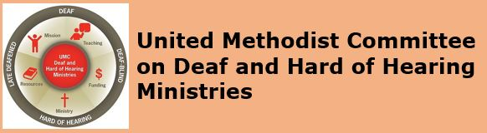
[Image Description: United Methodist Committee on Deaf & Hard of Hearing Ministries and its logo]
Monthly E-News - JULY 2019

Celebrate Disability Pride in July

New York celebrates Disability Pride Month each July and is an awareness campaign. It first came about during the 25th anniversary of the passing of the Americans with Disabilities Act (ADA). This celebration and parade occur each year that promotes the visibility and mainstream awareness of the positive pride of people with disabilities (differing abilities) within their communities. Disability Pride follows other movements, such as Black Pride and LGBTQ Pride. While New York celebrates Disability Pride all month long, other cities celebrate Disability Pride Week or Disability Pride Day at various times throughout the year. Have your church consider observing Disability Pride week in July or choose another week during the year.

Some late-deafened people (those with hearing loss after having been hearing), see their hearing loss as a form of disability (a loss of functioning) and prefer to hold onto their residual hearing, whereas many Deaf and hard of hearing people have pride in their deafness, Deaf history, and culture (they celebrate Deaf Awareness Week during the last week of September). Click here to learn more about late-deafened adults and resources. Deaf and hard of hearing people with a disability are sometimes referred to as Deaf+ (+ means having a disability with their deafness).

Goals of disability pride includes: changing the way people think about and define disability (different from the medical model), to end the internalized shame among some persons with disabilities feel, to see and value human diversity, and to promote awareness about ableism (discrimination and favoring abled body people). A side note, Deaf and hard of hearing persons experience audism (discrimination and favoring hearing people).

Your church can celebrate its own Disability Pride Week in July too (or partner with others). Churches can do some of the following (or be creative in other ways):
1. Include an announcement during worship that highlights it.
2. Invite a guest speaker from a non-profit organization to speak during a potluck meal
3. Post a Disability Pride Week sign on the church lawn.
4. Share accomplishments of persons with disabilities (e.g. Alexander Graham Bell was hard of hearing was an inventor) each Sunday during the announcements.
5. Be intentional and have persons with disabilities assist with worship (& perhaps have them be a permanent presence during worship).
6. Preach/teach about disabilities or about one type of disability (for instance, John the Baptist’s father, Zechariah, was temporarily deaf and mute – see Luke 1).
7. Complete an accessibility audit and/or a deaf-friendly accessibility audit and report the findings to church leadership or the church’s board of trustees.
8. Consider having a Disability/Deaf Awareness Sunday (The Book of Discipline requires each annual conference to choose a date; however, additional observances are encouraged).
9. Post additional awareness-related or church events specific to Disability Pride on the church’s social media.
10. Having a Sunday School class make up a bulletin board which promotes Disability Pride.

* Note: For those who have disability pride, some see the term differing abilities as a euphemism and feel it can mistakenly cause harm and cause people to have (internalize) shame about their disability. Some feel there is nothing wrong with saying disability and would rather not use the term differing abilities.

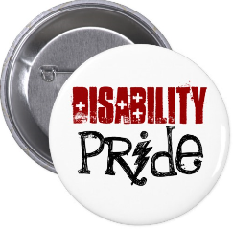
[Image Description: A button with the words disability pride.]

Deaf Ministry Spotlight
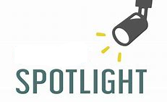
[Image Description: a spotlight shining on the word SPOTLIGHT.]

This month’s Deaf Ministry spotlight is St. Matthew United Methodist Church in Mesa, AZ. The ministry began in approximately 1984 when a deaf couple began worshipping at St. Matthew. They have an interpreting ministry, which makes their Sunday worship service accessible for Deaf and hard of hearing people in the Mesa area. The ministry offers periodic sign language classes. Their ministry even has 2 sign choirs: The Hands of Joy Sign Language Choir and The Hands of Praise Youth Sign Language Choir. The sign choir has performed all over Arizona helping to raise Deaf awareness and promote inclusion. The sign choir director is Gail Hahn and she can be reached at aghahn79@outlook.com. The church’s website is www.stmatthewmesa.org.
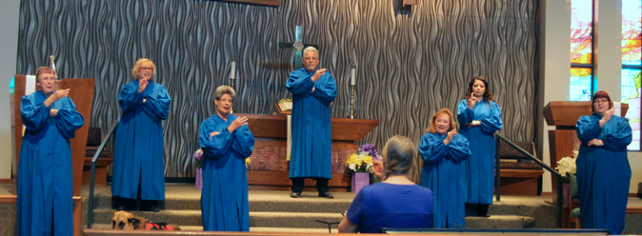
[Image Description: 7 signing choir members dressed in blue robes following/copying a choir director.]
* Highlight your Deaf ministry with us by emailing Rev. Yates at leoyjr@gmail.com.

Deaf Ministry Best Practice

Being a Deaf ministry ambassador is this month’s Deaf ministry best practice. Everyone who is involved in Deaf ministry ought to be an ambassador who helps to promote and bring visibility to Deaf ministry. As an ambassador, we should be ready to: speak about Deaf ministry, be advocates or allies, raise awareness about communication access (like point out barriers & recommend solutions), share resources (e.g. where sign language classes are offered or a book about Deaf ministry), plant seeds/ideas to other churches to begin a Deaf ministry (or at least how to improve communication access), know some of the history of your church’s Deaf ministry, and among other ambassador responsibilities. Remember, the Apostle Peter said to always be ready to give a testimony. “Always be ready to answer everyone who asks you to explain about the hope you have” (1 Peter 3:15 ICB). Being a Deaf ministry ambassador isn’t only for leadership, it’s for everyone who is involved in and/or supports the church’s Deaf ministry. So, put your Deaf ministry ambassador hat on and get to work!

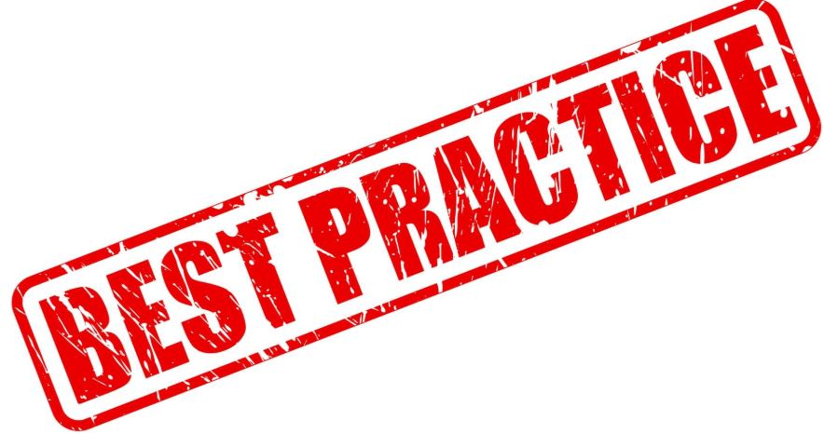
[Image Description: The words “Best Practice” stamped on a piece of paper.]

New Deaf Ministry Resource Book

A new Deaf Ministry resource book by Rev. Leo Yates, Jr. is Deaf Ministry: An Introduction to Ministry Models (2019). This book is a collection of readings from Yates’ other book, Deaf Ministry: A Comprehensive Overview of Ministry Models, 3rd Ed. As the title indicates, the book introduces readers to the various Deaf ministry models. It is an easier read and half the size (and half the price). A wonderful resource, the book can be shared with church leadership about beginning a Deaf ministry, for sharing with other churches who may be exploring the idea of beginning a Deaf ministry, and/or for sharing with newcomers to a Deaf ministry committee. The book is available in paperback and as an e-book on tablets by going to Amazon.com.

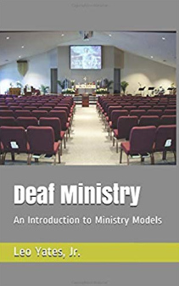
[Image Description: Book cover has an image of an empty sanctuary with the book title Deaf Ministry by Leo Yates, Jr.]

Deaf Ministry Support for Churches

The Deaf and Hard of Hearing Ministries Committee (of Global Ministries) is available to provide support and consultation for churches considering starting a Deaf ministry. Consultation can include how to implement a Deaf ministry, how to promote a Deaf ministry, how to have a Deaf-friendly worship service, what resources are available, to discuss available grants and other funding sources, and among other needs. Contact the Rev. Leo Yates, Jr. at leoyjr@gmail.com.


[Image Description: A blue and gray ribbon with the words Free Consultation.]

Upcoming Deaf Ministry Boot Camp in GA

Mount Pisgah UMC in Johns Creek, GA is hosting a Deaf Ministry Boot Camp on September 21, 2019 from 10am to 2pm. This exciting and interactive workshop will be presented by the Deaf & Hard of Hearing Ministries. Registration is free, but participants are required to RSVP (to plan for lunch). Participants will learn some basic sign phrases, ministry ideas, improve communication access, ways to begin a Deaf ministry, and more. Click here to learn more about the workshop and to register for the event. Contact the Rev. Leo Yates, Jr. at leoyjr@gmail.com if you have specific questions about the workshop. Email reasonable accommodation requests by September 7th to Stephen Taylor at staylor@sns360.org.

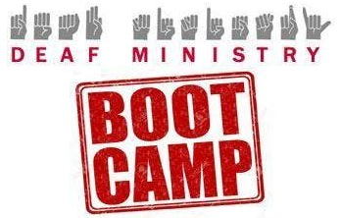
[Image Description: Deaf Ministry is displayed in English and the manual alphabet with the stamp Boot Camp.]

FOLLOW US
Follow us on Facebook
Follow us on Pinterest
Follow us on Twitter

Check out our sister committees and organizations:
DisAbility Ministries Committee
United Methodist Association of Ministers with Disabilities
United Methodist Congress of the Deaf
Mental Health Ministries

Copyright © * 2019 * Global Ministries Committee on Deaf and Hard of Hearing Ministries *, All rights reserved. Website: www.umdeaf.org. Email questions or comments to umdeaf@gmail.com Mailing address:
General Board of Global Ministries
Attn: Sabrina Rodgers
458 Ponce De Leone Ave NE
Atlanta, GA 30308

