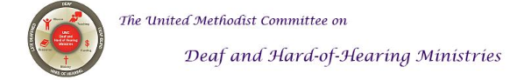
SPRING2018
To share Jesus’ love by equipping and advocating access through effective communication and leadership among the diverse Deaf, Hard-of-Hearing, Late-Deafened, and Deaf-blind communities.

Headlines: Deaf Ministry Conference Planned for Las Vegas
The United Methodist Congress of the Deaf (UMCD) is co-planning an ecumenical Deaf Ministry conference this summer to be held in Las Vegas, Nevada. Denominational representatives planning the conference are from The United Methodist Church, the Episcopal Church and The Lutheran Church. More precisely, representatives are from the Episcopal Congress of the Deaf, Evangelical Lutheran Deaf Association, and the United Methodist Congress of the Deaf. The three Deaf representative bodies formed the ELM partnership a few years ago. The conference theme is "Sharing Hands with love." The dates are Thursday, July 26-Saturday July 28th with a farewell planned for Sunday, July 29th. The conference will be held at the Tuscany Suites and Casino [www.tuscanylv.com].For conference information, contact Donald Rosenkjar at donkhai99@aol.com. United Methodists can contact Rev. Tom Hudspeth at thudspeth@llumc.org. Conference registration is located on the UMCD website [www.umcd.org].

Pre-conference events include:
* A United Methodist Certified Lay Servant training is July 23-24. (Suggest arriving on July 22.)
* The United Methodist Committee on Deaf and Hard of Hearing Ministries meeting is July 25-26. (Suggest arriving on July 24.)
* The United Methodist Congress of the Deaf business meeting is Wed, July 25-26. (Suggest arriving on July 24.)
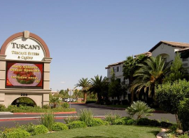
[Image description: A picture of the Tuscany hotel.]

Deaf Ministry Best Practice
This quarter's Deaf ministry best practice is having Deaf-friendly worship service. Deaf-friendly worship services have elements that include: accessibility, the use of visuals, and hospitality. One example of accessibility is ensuring worship leaders use a sound system throughout the service so hard of hearing and late-deafened individuals are sure to be included. Another example is including the [ASL] manual alphabet in the bulletin (or use a bulletin insert). Still, another example is using a multimedia projector that displays music lyrics (remember, Deaf people need their hands free to sign the music and cannot hold the hymnal at the same time). This committee offers a brochure that offers guidance. An online article by the UM Insight is worth reading as well. It can located by clicking here [https://um-insight.net/topics/deaf/].
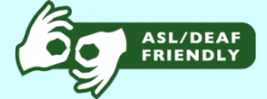
[Image description: The ASL sign for interpreting with the words "ASL/Deaf Friendly."]

ASL Tutoring
The United Methodist Committee on Deaf and Hard of Hearing Ministries is offering free ASL tutoring to churches that do not yet have a Deaf ministry. ASL (American Sign Language) tutoring is being offered to help raise Deaf awareness and foster interest in learning in ASL. This is offered via Skype, FaceTime, or Zoom. The ASL tutoring includes practicing the manual alphabet (the ABCs), an introduction to sign phrases, introduced to some religious/church signs (i.e. church), and an overview of Deaf culture. To sign up or to request more information, contact the Rev. Leo Yates, Jr. at leoyjr@gmail.com.
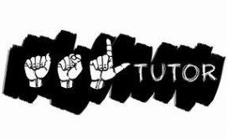
[Image Description: The words ASL in sign language and the word Tutor.]

Advocacy Moment
Advocates for the Americans with Disabilities Act (ADA) are upset that the U.S. Congress is considering making revisions to the ADA that loses some of the protection, such as the enforcement of accommodations by businesses. Known as the HR 620 bill, the ADA Education and Reform Act, it has already passed by the House. The bill has now gone to the Senate to be discussed and voted upon. Part of the reason for the bill is some of the frivolous lawsuits; however, it provides businesses more time to make accommodations. If passed, it will delay accommodations being given to people with disabilities when businesses already have ample time to do so. Advocacy groups are encouraging people with disabilities and their allies to contact their senators to vote NO to the HR 620 bill. Click here [www.govtrack.us/congress/bills/115/hr620] to follow the bill and read more about it.

To locate your senator's information, click here [www.senate.gov/general/contact_information/senators_cfm.cfm] . It has email information and telephone numbers. Calling is always better, but an email can still be useful. They need to hear from you and our allies/supporters of the ADA.
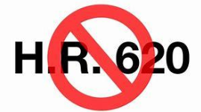
[Image description: The phrase HR 620 strike out.]

Congregational Resource: Brochures
The United Methodist Committee on Deaf and Hard of Hearing Ministries created new electronic brochures available for download. The brochures can supplement the church’s Deaf awareness campaign, use them to highlight observances such as Deaf Awareness Week, or as a part of its strategy to promote its Deaf ministry with the congregation or wider community. The brochures are available by clicking here [www.umdeaf.org/resource/cong.html]. Once downloaded, print using your regular copy paper or use 28lb paper (higher quality paper). Brochures available are:
1. Tips for Communicating with People who are Hard of Hearing and Late-Deafened
2. Guidance for Learning Deaf Culture and Sign Language
3. Tips for Working with a Sign Language Interpreter
4. Guidance for a Deaf-blind Ministry
5. Guidance for Implementing a Deaf Ministry
6. Guidance for Hospitality and a Deaf-Friendly Worship
As new brochures or new resources are made available, they too will be announced.
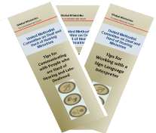
[Image description: Image of 3 brochures.]

Interpreting Ministry Best Practice
This quarter’s interpreting ministry’s best practice is ask what is the church’s primary theology. Sometimes, it may be the denomination’s theology and/or it may be specific to the church’s community or context. Simply explained, theology means an understanding of God and the values, beliefs, attitudes, and ideas that support that understanding. For example, The United Methodist Church’s foundational theology, while various, traces its roots back to Wesleyan theology (the theology and writings of the denomination’s founder, John Wesley), which emphasizes grace. Because there are various theologies, it’s better that the interpreter knows his or her own values and beliefs regarding faith so he or she isn’t uncomfortable or distressed with a worship service that may not theologically fit the interpreter’s theology (values and beliefs). One reason for this is the interpreter may accidentally (or purposefully) influence the message being interpreted. Often, a church’s theology is located on the church’s “history” or “about us” webpage on the church’s website.
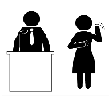
[Image description: Clip art of an interpreter with a speaker.]

Consulting and Trainings
Part of the work of the United Methodist Committee on Deaf and Hard of Hearing Ministries is to provide consulting and trainings for United Methodist churches. If your church is considering implementing a Deaf ministry, then contact Rev. Leo Yates, Jr. at leoyjr@gmail.com. He or one of the committee members can assist your church or ministry.
TRAININGS INCLUDE:
* Promoting Your Deaf Ministry
* Overview of Deaf Ministry Models
* How to Begin a Deaf Ministry
* Best Practices & Strategies
* Sign Language Interpreting
* Signing Music and Christian Dramas

[Image description: Clipart of two people in a meeting.]

Deaf Awareness Opportunity
May is Better Hearing and Speech Month. There’s no better time than to promote Deaf awareness in the spring time. Ways to raise awareness includes: (1) bulletin inserts (use a new insert each week), (2) post articles on the church bulletin board, (3) include a special article in the church newsletter, (4) share it during worship announcements, (5) host a Deaf Awareness Sunday,(6) put out some Deaf and hard of hearing related materials or brochures on the church resource table (or set up a table for the month), (7) share hearing screening forms (or promote the idea), and/or (8) host a sign language class. Specific materials and more ideas can be found at the American Speech-Language-Hearing Association’s website. Click here [www.asha.org/bhsm/] for the website.
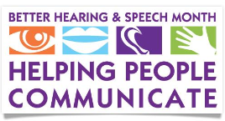
[Image description: Clip art of Better Hearing & Speech Month with the phrase, "Helping People Communicate."]

Deaf Ministry: A Closer Look
At Epworth United Methodist Church in Rehoboth Beach, Delaware, it began a new online streaming ministry that includes a sign language interpreter during the 9:15am service. The church applied for a grant through the United Methodist Committee on Deaf and Hard of Hearing Ministries and also raised funds to support this new ministry. By having the online streaming ministry, it enables worship services to be recorded and saved. Click here [www.eumcrb.org/deafvideos/] to see a sample. In the works, is to have a split screen that will eventually have a dedicated screen displaying the sign language interpreter and the service on the other screen. The church envisions the new live streaming ministry will provide accessibility and connect to Deaf and hard of hearing individuals who desire online access to worship, especially if distance is a barrier. If visiting the beach, be sure to stop by and visit one Sunday. For more information, go to the church’s website at www.eumcrb.org.
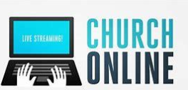
[Image description: Clipart of hands on a laptop with the words, "Church Online."]
To have your church or ministry highlighted in a future newsletter, please contact Rev. Leo Yates, Jr. at leoyjr@gmail.com. We would love to hear from you.

Disability Leadership Academy
The United Methodist Association of Ministers with Disabilities is hosting a Disability Leadership Academy: Taking Our Place at the Table. It will be held at the Kellogg Conference Hotel (on Gallaudet University campus) in Washington, DC from August 1 - 3, 2018. This conference is designed to bring us together for training, conversation and strategic thinking. Click here [www.umdisabledministers.org/meeting/2018.html] for more information.
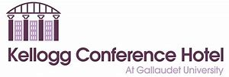
Quick Links
DisAbility Ministries Committee of the UMC

The VOICE of the United Methodist Disability Connection
(Newsletter)

UM Association of Ministers with Disabilities

UM Committee on Deaf and Hard of Hearing Ministries

Donate through The Advance
Newsletter Archives

Follow Us on Social Media
Check out our Deaf and Hard of Hearing Ministries website [www.umdeaf.org] and
Follow us on Twitter.
Follow us on Facebook.
Follow us on Pinterest.

Facebook has been changing how your news feed works lately. If you are not seeing our posts, go to our page and mark "see first" under "following." You will also see more of our posts if you click one of the "like" buttons or icons on the posts. Please keep in mind that the more you click "like," the more Facebook will show the posts to others: it's a way to share our mission!

United Methodist Committee on Deaf and Hard of Hearing Ministries
Global Ministries of The United Methodist Church
458 Ponce De Leon Ave NE, Atlanta, GA 30308

