
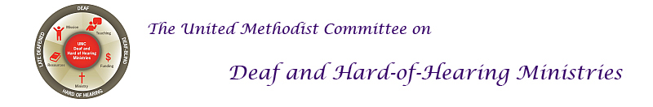
Holiday Edition 2017
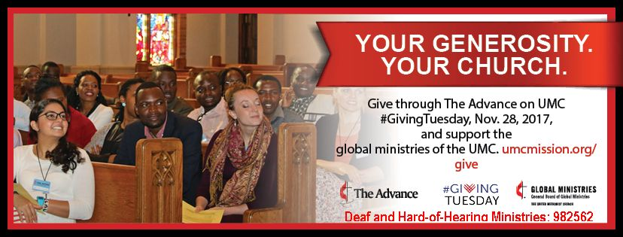[Image description: A congregation with the message "Your Generosity. Your Church." that invites people to support the Deaf and Hard of Hearing Ministries Advance.]

The United Methodist Committee on Deaf and Hard of Hearing Ministries serves those who are Deaf, hard of hearing, late-deafened, and Deafblind. This is most prominent when we provide grants to ministries, churches, districts, and annual conferences who in turn support the ministry, inclusion, accessibility, and empowerment of this population. With your help, the United Methodist Committee on Deaf and Hard of Hearing Ministries can continue to support programs and ministries, which include leadership development. Won't you consider a donation on Giving Tuesday on Tuesday, November 28th? Every dollar counts.

Some projects that were supported by grants include:

1. Supporting individuals to attend summer camp.

2. Purchasing and installing an assistive listening system for a sanctuary.

3. Scholarship for a hard of hearing seminary student.

4. Hosting a Deaf conference.

5. Supporting a Deaf seniors program.

It's easy to make a donation. Go to www.umcmission.org/give. Use this ministry's Advance number #982562.
Give Online:
You can give to any of the ministries, missionaries, and projects currently supported by The United Methodist Church through Global Ministries. Give online now.
By Phone:
Credit card gifts can be accepted by phone. The telephone number is: 888-252-6174 toll-free.
By Mail:
Make your check payable to ADVANCE GCFA. Write the Advance code number (#982562) on the memo line of the check.
Send your check to:
Advance GCFA
P.O. Box 9068
New York, NY 10087-9068.
We appreciate your support!

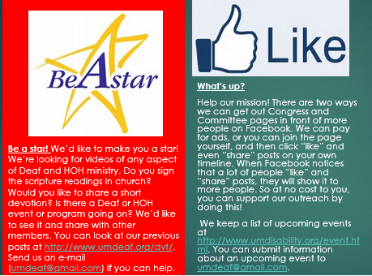
[Image description: The first image, "Be a Star," invites people to submit videos from their church. The "Like" image invites people to "like" our Facebook posts, as well as learn of future disability-related events.]
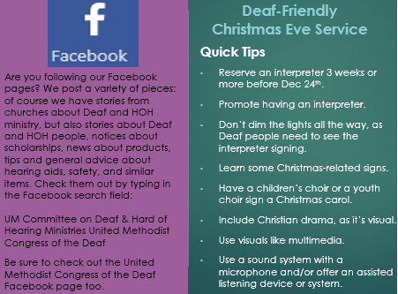
[Image description: The Facebook image invites people to follow us on Facebook. The Deaf-Friendly Christmas Eve Service image provides "quick tips" that includes reserving an interpreter a head of time
and not dimming lights all the way as deaf people need to see the sign language interpreter.]

Need Congregational Resources?
Consider one of the following:
1. A Brief Guide to Sign Language Interpreting (& how to acquire them).
2. A Guide to Ministry with Hard of Hearing and Late-Deafened People.
3. A Guide to Hospitality for Deaf and Hard of Hearing Visitors.
4. A Brief Guide to Deafblind Interpreting.

For more resources, click here.

Free Virtual Sign Language Classes
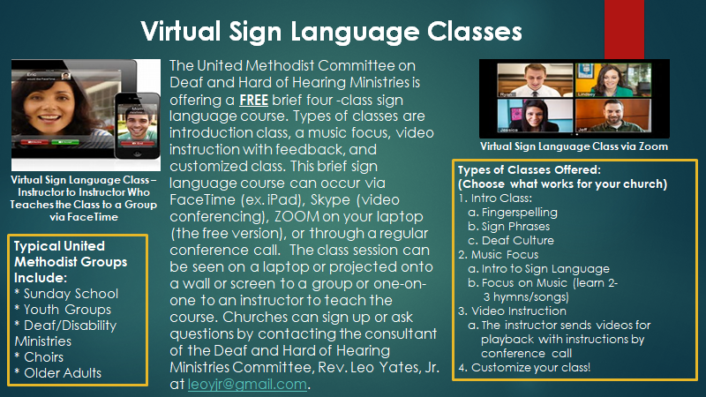
[Image description: An ad for virtual sign language classes that has an overview of the virtual class (1. intro to ASL, 2. Signing music, 3. Video instruction, and 4. Customized class), types of groups to take the class (ex. Sunday School, youth group, choir), and 2 images of video conferencing.]

Christmas Vocabulary in Sign Language
Take a moment and learn some Christmas-related signs by checking out this YouTube video.
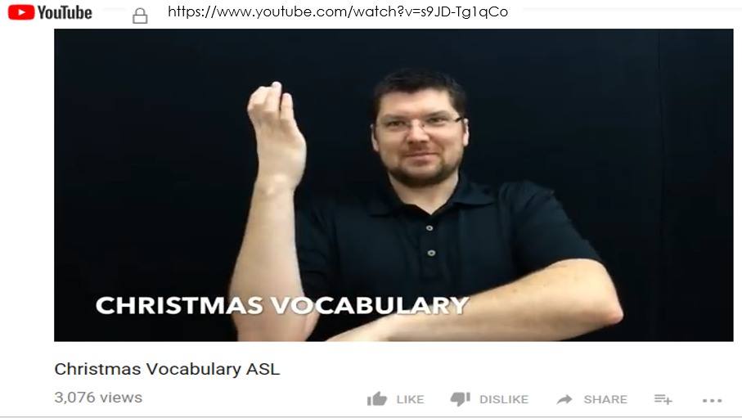
[Image description: An image of a YouTube video of a man teaching Christmas vocabulary in sign language with a link to the video.]

https://www.youtube.com/watch?v=s9JD-Tg1qCo&t=172s
Christmas Songs in Sign Language
Interested in learning a few Christmas songs in sign language? Check out this YouTube channel.
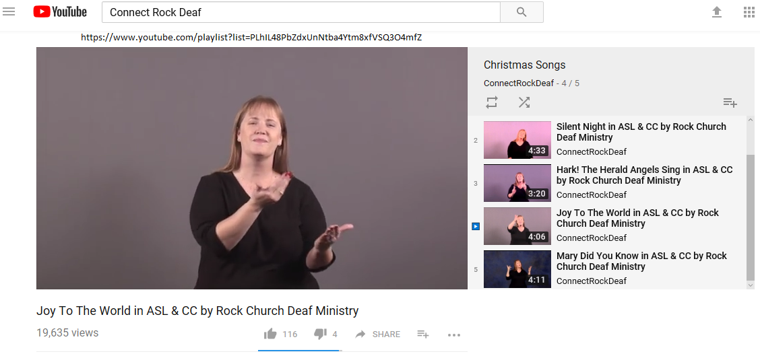
[Image description: A YouTube video of a woman signing a song with a link to other videos for Christmas songs.]

https://www.youtube.com/playlist?list=PLhIL48PbZdxUnNtba4Ytm8xfVSQ3O4mfZ

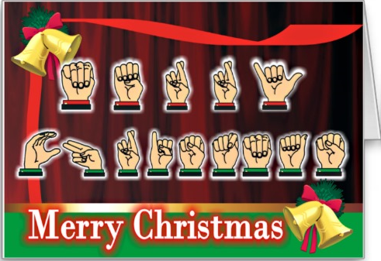
[Image description: An image of Merry Christmas spelled out in American Sign Language (the alphabet)].

Check out our Deaf and Hard of Hearing Ministries website at www.umdeaf.org

Follow us on Facebook.
Follow us on Twitter.
Follow us on Pinterest.

