United Methodist Committee on Deaf and Hard of Hearing Ministries Committee
Contact Rev. Leo Yates, Jr. at leoyjr@gmail.com for additional information or for a consultation. Also, contact him to receive our quarterly newsletter. The newsletter includes resources, best practices, national and local Deaf ministry news, and so on.
www.umdeaf.org
General Board of Global Ministries
The United Methodist Church
458 Ponce De Leon Ave NE
Atlanta, GA 30308

United Methodist Committee on Deaf and Hard of Hearing Ministries
www.umdeaf.org
United Methodist Association of Ministers with Disabilities
www.umdisabledministers.org
DisAbility Ministries Committee
of The United Methodist Church
www.umdisabilityministries.org
The United Methodist
Congress of the Deaf
www.umcd.org
How to Support the Committee
Give to the Advance:
By Check:
Make payable to your local church or “Advance GCFA.” Be sure to write Advance #982562 and “Committee on Deaf and Hard of Hearing Ministries” on the check. For local church and annual conference credit, give your gift to your local church treasurer.
By Credit Card:
Call 1-888-252-6174 or go to http://www.umcmission.org/Give-to-Mission/Search-for-Projects/Projects/982562.

United Methodist Committee on Deaf and Hard of Hearing Ministries
Global Ministries
The United Methodist Church

UNITED METHODIST COMMITTEE ON DEAF AND HARD OF HEARING MINISTRIES

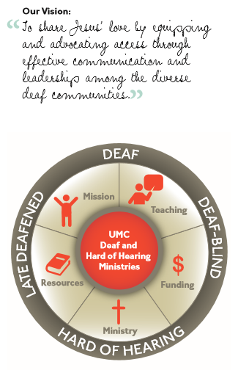

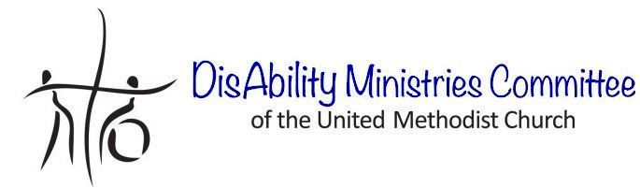 Check out our sister committee,
DisAbility Ministries Committee
of The United Methodist Church www.umdisabilityministries.org
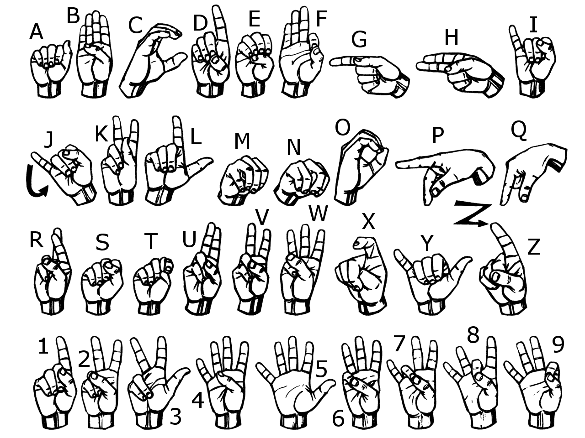

The United Methodist Committee on
Deaf and Hard of Hearing Ministries
Provides funding for Deaf communities to engage in ministry with United Methodist churches. This community is largely unchurched due to ineffective communication and lack of Deaf Christian leadership development. When United Methodist churches open their doors so that those who are Deaf, hard of hearing, late-deafened, or Deafblind may participate more fully in worship, mission, and, ministry, the Church and the world are enriched.
Gifts by individuals, families, churches, and the denomination helps share Jesus’ love by providing effective means of communication and leadership among churches, Deaf communities, and individuals. Grants offered by the committee will assist in partnering and networking with churches that are establishing or have a Deaf ministry, including:
- Seed money to establish new ministries with the Deaf community
- Mission and ministry internships
- Global outreach to Deaf, hard of hearing, late-deafened, and Deafblind people.
- Opportunities for camping, such as Deaf and Deafblind camps
- Communication access assistance: assistive listening devices, sign language or oral interpreters, real-time text translation, and so on. Such assistance is not intended as on-going, long-term solution to access, but for start- up or special event assistance.

Advocacy
We believe that advocating for technologies and effective communication, as well training Deaf and hard of hearing Christian leaders can tract Christian growth among the Deaf community. We share Jesus’ love by advocating for and with those who struggle to respond to God’s initiation to be part of Christ’s body. We are called to “not curse the deaf” (Leviticus 19:14), and to encourage all people, including those who are Deaf and hard of hearing to participate in the blessings of God’s creation and saving work.

Grants and Scholarships
For more information about grants and scholarships offered by the committee, please check out the committee’s website. Grant application cycles close every January and July.

Who We Serve
We serve four distinct deaf groups: Deaf, hard of hearing, late-deafened, and Deafblind. Deaf people view deafness not as a disability, but as a way of life and culture, because of the use of sign language – American Sign Language or other indigenous signs. Hence, the capital letter “D” in Deaf. For those who are hard of hearing may struggle to relate to hearing peers, but have often adapted to a combination of communication modalities and medical technologies such as cochlear implants in order to relate to others. For those who are late-deafened, may are unfamiliar or reluctant with audio/verbal modalities and assistive listening technologies to aid in communicating with their hearing peers. Deafblind people may communicate through tactile signing, Braille, and assistive technologies. All of these groups have unique skills and needs to thrive in the Deaf and hearing world.

Congregational Resources
The United Methodist Committee on Deaf and Hard of Hearing Ministries offers several congregational resources on its website. It can be located at www.umdeaf.org. Congregational resources offered include, but not limited to:
- A Brief Guide to Beginning a Deaf Ministry
- Online Sign Language Classes & Dictionaries
- A Brief Guide to Hospitality for Deaf and Hard of Hearing Visitors
- A Brief Guide to Assistive Listening Devices
- A Brief Guide to Sign Language Interpreting
- Breaking the Sound Barrier: Mission and Ministry with People Who Are Hard of Hearing or Late-Deafened
A helpful resource is the book, Deaf Ministry: Ministry Models for Expanding the Kingdom of God, by Rev. Leo Yates, Jr. It gives a thorough overview of various Deaf ministry models, as well as plan for beginning a Deaf ministry. Bishop Peggy Johnson’s book, Deaf Ministry: Make a Joyful Silence, is inspirational and offers devotionals by Robert Walker. These can be purchased at Amazon.com.
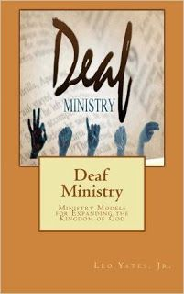 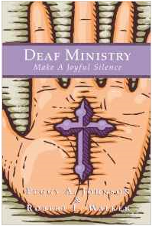
By Leo Yates, Jr. By Peggy A. Johnson and
Robert L. Walker

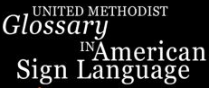
Be sure to check these out!

