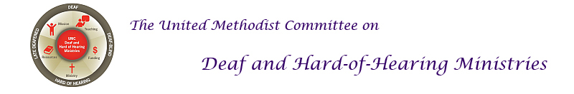

DEAF AWARENESS SUNDAY
Deaf Awareness Sunday can be celebrated just about any Sunday during the year. An ideal time is during Deaf Awareness Month in September. A typical Deaf Awareness Sunday highlights deafness, Deaf culture, and includes Deaf, hard-of-hearing, late-deafened, and Deaf-blind individuals in the service, which might include hearing individuals who are proficient in sign language. A Deaf Awareness Sunday will also include aspects of accessibility, a Deaf-friendly worship service, and teaching moments.
Accessibility Ideas include:
- Have a captionist or display captions on videos or displaying captions through Otter.ai or a similar service.
- Have a sign language interpreter as a part of the service.
- Include the ASL manual alphabet in the bulletin, such as this one: https://i.pinimg.com/736x/fa/bb/70/fabb7087b0cffe30530e7df9ec1d0b88.jpg.
- Announce that the church offers an assistive listening system/device and/or include its availability in the bulletin.
- Offer large print bulletins for any Deaf-blind individuals. Include a blurb in the bulletin that they’re available.
- Share briefly or highlight Deaf etiquette and/or how to work with an interpreter.
A resource on Deaf etiquette: www.theabilitycenter.org/docs/Deafetiquette.pdf
- Touch on the American with Disabilities Act (ADA): churches aren't legally required to follow, but push as an example of the justice to which we are called, in accordance with the Discipline.
Deaf Culture Ideas include:
- Highlight sign language throughout the service.
- A 1–2-minute history of ASL or Deaf history during announcements.
Here is a link to its brief history: http://lifeprint.com/asl101/pages-layout/history1.htm.
- Another consideration is to explain the distinctions between Deaf, hard-of-hearing, late-deafened, and Deaf-blind people, perhaps during announcements.
Here are definitions: https://www.nad.org/resources/american-sign-language/community-and-culture-frequently-asked-questions/ .
- Discuss some aspect(s) of what the Deaf community is like. Include a short list of some Deaf and hard-of-hearing celebrities. Here’s a list: www.startasl.com/famous-deaf-people.html.
- Emphasize some differences between hearing culture and Deaf culture (perhaps through role play).
- Teach some signs from the ASL United Methodist Glossary, whether in Sunday School, during a group study, in worship, and/or promote it
https://www.youtube.com/playlist?list=PLByvp1Kd0Uovxt1d6jBZtxekS1CFq_cXW
- Include a bulletin insert. Here are some
https://www.umdeaf.org/resource/cong.html
Deaf-friendly Worship Ideas include:
- Use the sound system consistently so hard-of-hearing and late-deafened people are able to hear or better hear.
- Teach a song or a prayer in sign language (e.g. Jesus Loves Me in the children’s message or the Lord’s Prayer to the congregation).
- Have a Deaf person help lead worship and/or sign the scripture reading. Have a sign language interpreter from the pew voice out loud what the Deaf person is signing.
- A sermon that speaks to including all people, while emphasizing Deaf, hard-of-hearing, late-deafened, and Deafblind people. This can be the regular pastor who preaches with an interpreter or a preacher who is Deaf or who signs.
Sermon Tips: Mark 7:31-37 touches on Deaf people or being open to Deaf people; 1 Corinthians 1-11 touches on the spiritual gifts of Deaf people; 1 Corinthians 12:12-31 touches on the diversity of the body of Christ.
- Make the service more visual that might include the use of multimedia, a Christian drama, and/or liturgical dancing.
- Have a soloist or a choir (or a few members of the choir) sign a song or two, like a children’s choir or a youth choir.

Promoting the Event
Be sure to promote the Deaf Awareness Sunday in your community. Ideas for promoting it include:
    - Hearing Aid Centers
    - Ear, Nose, and Throat doctor’s offices, including audiologist offices
    - Public libraries
    - Announce it on the church sign
    - Post a flyer on the bulletin boards
    - Announce it each week in the bulletin 3 to 4 weeks in advance
    - Other Deaf ministries in the community
    - Any schools that have a sign language class (a high school or college)
    - On the church website (in case guests look up the church’s website prior to it)
    - Social media

DEAF MINISTRY SUNDAY
A Deaf Ministry Sunday is often planned and led by the Deaf ministry of the church (or perhaps its committee). It also includes aspects of a Deaf Awareness Sunday (accessibility, Deaf culture, and a Deaf-friendly worship service). In addition, it can highlight the work of the Deaf ministry, and can emphasize any involvement in the community. It can include:
- A preacher who is Deaf or a hearing person who is proficient in sign language.
- Receiving a testimony or two of some of the Deaf ministry (a short video of ministry highlights).
- A sign choir that includes your Deaf, hard-of-hearing, late-deafened, Deaf-blind people, and hearing people. Or invite a Deaf/signing choir.
- Teach a few signs or sign phrases during the announcements or during the children’s sermon.
- Consider asking Deaf, hard-of-hearing, late-deafened, and/or Deaf-blind individuals to be greeters and/or ushers who will pass out bulletins and/or take up the offering.
- A children’s sermon that has the game “red light – green light”; after you have a winner, explain to the children how we all need to take the time to slow down (not be in a rush), so we can learn sign language and have relationships with Deaf and hard-of-hearing people. Be sure to teach a few signs as well. (Details of how to play the red light-green light game is found here: www.gameskidsplay.net/games/sensing_games/rl_gl.htm.
- A combination of your regular service with aspects of your Deaf ministry can be done as well.
- A resource table during coffee/donut hour that offers brochures about deafness and hearing loss, accessibility, and/or information about your Deaf ministry.
Deaf and Hard of Hearing Ministries Committee has resources here: https://www.umdeaf.org/resource/cong.html
Deaf-blind resources can be found here: www.nationaldb.org/info-center/
Hearing Loss Association of America brochures can be found here: http://hearingloss.org/news-media/brochure-downloads/
- Announce any new missions the Deaf ministry is implementing or is currently involved with.
- Invite special guests who can make the worship service even more enjoyable or worshipful.
- Try to include Deaf culture, Deaf people, and the Deaf experience throughout worship.
- Host a special lunch after worship that includes a Q and A about Deaf ministry, ministry highlights, or a guest speaker.
Reference
Yates, L. (2021). Deaf Ministries: Ministry Models for Expanding the Kingdom of God, 4th Ed. Charlotte, NC: KDP Publishing, Inc.

Worship Liturgy Suggestions
OPENING LITANY / CALL TO WORSHIP
Leader: God is good. | 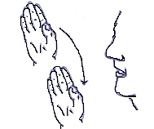  GOD GOOD
People: All the time | 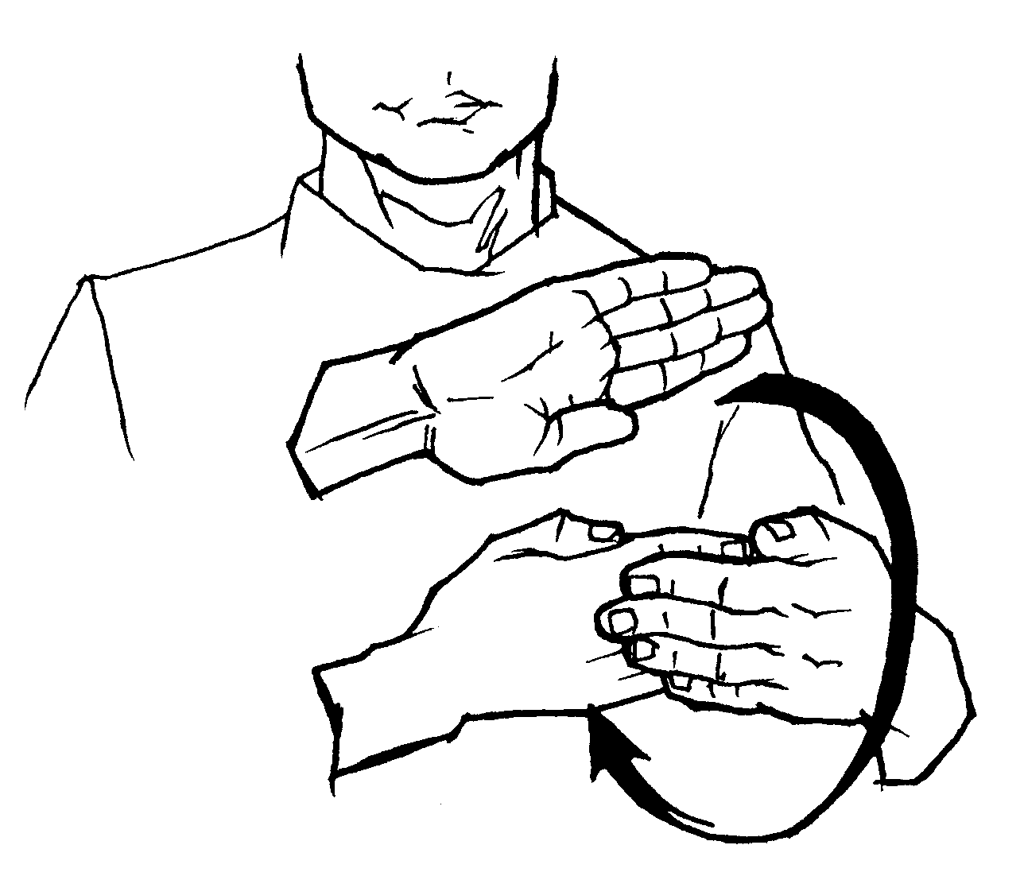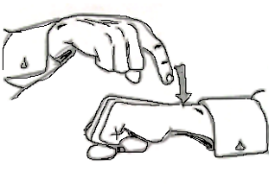  ALL TIME
Leader: All the time | ASL sign  ALL TIME
People: God is good. | GOD GOOD
All: Amen | 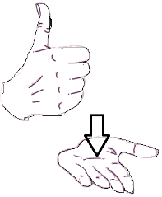  AMEN

OPENING PRAYER
Holy God, we thank you for the diversity of your Creation. From Deaf, hard of hearing, late-deafened, Deafblind, and hearing people, you created us all in your loving image. We gather on this day, not only to worship you, but to praise your holy name! May your name be praised in sign language and also spoken everywhere, this day and this very hour. Amen.
THE LORD’S PRAYER IN ASL
Have the congregation sign it together or have someone learn it and sign it during the service. Having a tablet or iPad on a music stand may make it easier for the person signing it.
https://www.youtube.com/watch?v=wvK0poYIAr8

SCRIPTURE READING: Psalm 117:1 & 2b
1. Praise the Lord | (applause) (using your right hand, the letter “L”  signed from the left shoulder  to the right hip)  PRAISE LORD
all you nations | (make a circular motion  near the elbow)  ALL COUNTRY
extol him, | HONOR GOD
all you peoples. | (point toward the people) (use a “p” handshape)  ALL YOU PEOPLE
2 (b) Praise the Lord. | (applause) (use a “L” handshape, from shoulder to hip)  PRAISE LORD

CHILDREN’S SERMON
Scripture Verse: 1 Corinthians 12:27: Now you are the body of Christ and each one of you is a part of it.
Theme: Diversity, Hospitality, Welcoming, Deafness
Lesson: Teach the children about being a welcoming church and how learning sign language, even a few sign phrases show Deaf and hard of hearing people – people with hearing loss – that they are welcomed and also belong here. While many people with hearing loss do not know sign language, some do, either from childhood or those who learned it as their primary language due to moderate to severe hearing loss or they learn it later in life (they’re sometimes referred to as late-deafened). Paul wrote to the church in Corinth and emphasized how we are to be welcoming to all people, this includes deaf, hard of hearing, late-deafened, and deafblind. Let’s try to remember to smile, say/sign hello, and welcome them. One way to welcome them is by signing, “Jesus loves you.” Close with prayer.
JESUS  The sign for Jesus references the nail marks on his hands. | JESUS
LOVES  The sign comes from hug or hugging. It’s a sign of affection. | LOVES
YOU  It is a matter of pointing to the person that lets them know you are referring to them. | (point to the person / in their direction)
I LOVE YOU
This is a combination of the sign “I” and “l” and “y” that makes up the sign for I love you. It is a common sign expressed / signed by people in the Deaf community. They often share a lot of love. The world would be a better place if we all said this to others more often, right?

HYMN: Praise Him
Praise Him. | (applause) (pointing toward heaven)  PRAISE HIM
Praise Him. | (applause) (pointing toward heaven)  PRAISE HIM
Praise Him in the morning. | 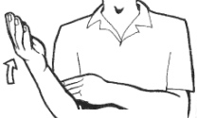  (applause) (pointing toward heaven)  PRAISE HIM MORNING
Praise Him in the noon time. | 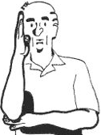  (applause) (pointing toward heaven)  PRAISE HIM NOON TIME
Praise Him. Praise Him. | (applause) (point upward) (applause) (point upward)  PRAISE HIM PRAISE HIM
Praise Him when the sun goes down | (applause) (pointing toward heaven)  PRAISE HIM NIGHT
Continued: Praise Him
Serve Him. | (pointing toward heaven)  SERVE HIM
Serve Him. | (pointing toward heaven)  SERVE HIM
Serve Him in the morning. | (pointing toward heaven)  SERVE HIM MORNING
Serve Him in the noon time. | (pointing toward heaven)  SERVE HIM NOON TIME
Serve Him, serve Him. | (point upward) (point upward)  SERVE HIM SERVE HIM
Serve Him when the sun goes down. | (point upward)  SERVE HIM NIGHT

CLOSING PRAYER
O God, as we conclude our worship, we continue to worship you in our hearts. With the help of your love, enable us to be intentional in welcoming all of your people, especially our Deaf, hard of hearing, late-deafened, and Deafblind brothers and sisters. Help prepare our congregation to be welcoming to them so we will better represent the body of Christ to the world. And, if your (Lord’s) table represented here at our church needs to utilize assistive listening equipment, sign language interpreters, captioning, and other communication tools, then help us to do these. Lord, we have faith in that, if they come, you will help us to find a way to welcome them. May your Spirit show us the way. We pray this in Jesus’ name. Amen.
BENEDICTION
As we now go out into the world, changed and equipped to be ambassadors of Christ, remember to smile and wave hello if you have meet Deaf and hard of hearing people. Extend the church’s hospitality by being a friend in Christ. Go and serve the Lord. Amen.

