**General Board of Global Ministries**

**The United Methodist Church**

**458 Ponce De Leone Ave NE**     
**Atlanta, GA 30308**

**www.umcmission.org**

**United Methodist Committee on Deaf and Hard of Hearing Ministries**  
www.umdeaf.org

**United Methodist Association of Ministers with Disabilities**  
www.umdisabledministers.org

**Disability Ministries Committee  
of The** **United Methodist Church**  
www.umcdmc.org

**The United Methodist   
Congress of the Deaf**  
www.umcd.org

**How to Support the Committee  
Give to the Advance:**By Check:  
Make payable to “Advance GCFA.” Be sure to write Advance #982562 and “Deaf and Hard of Hearing Ministries” on the check. Send Checks to   
The Advance  
458 Ponce De Leon Ave, NE  
Atlanta, GA 30308  
  
By Credit Card:  
Call 1-888-252-6174 or go to www.umcmission.org/Give and search for Advance #982562.

**United Methodist Committee on   
Deaf and Hard of Hearing   
Ministries Committee**  
Contact the committee to learn more and for more information. Also, enroll to receive our quarterly newsletter. The newsletter includes resources, best practices, national and local Deaf ministry news, and other information.  
www.umdeaf.org

**UNITED METHODIST COMMITTEE ON DEAF AND HARD OF HEARING MINISTRIES**

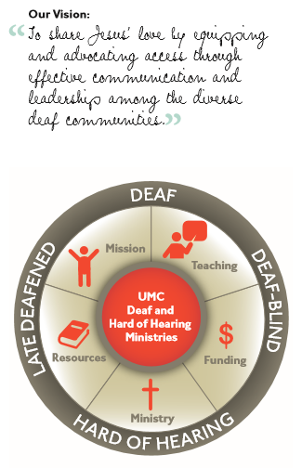

Check out our sister committee,   
Disability Ministries Committee   
of The United Methodist Church www.umcdmc.org  
decorative border  
 **Additional Resources**

For additional congregational resources, visit the United Methodist Congress of the Deaf’s website   
at www.umdeaf.org.

A helpful resource is *Deaf Ministry: Ministry Models for Expanding the Kingdom of God, 4th Ed* by Leo Yates, Jr. It can be purchased at Amazon.com.

“To share Jesus’ love by equipping and advocating access through effective communication and leadership among the diverse  
Deaf communities.”

**Tips for Communicating   
with People who are Hard of Hearing and Late-Deafened**



**United Methodist Committee on Deaf and Hard of Hearing Ministries**

**Global Ministries**  
The United Methodist Church

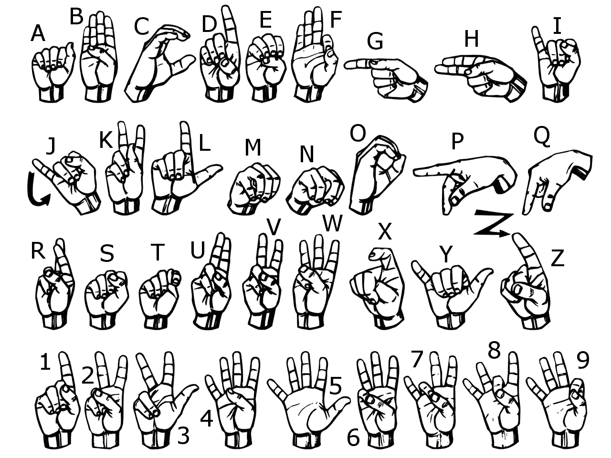

**The United Methodist Committee on   
Deaf and Hard of Hearing Ministries** is a Global Ministries committee. The committee provides resources, consultation, cultivates Deaf ministries, educates congregations, helps to develop Deaf leaders, and offers grants to United Methodist churches. Helpful to know is when reading a capital ‘D’ in the word deaf, it indicates cultural deafness within what is discussed or stated. Besides indicating hearing loss, the small ‘d’ in deaf indicates someone who is not culturally Deaf.

**Hard of Hearing and Late-Deafened**

The term hard of hearing refers to people who can understand spoken speech with the help of amplified sound through an assisted listening device, a hearing aid, or by lip-reading. Persons may be born hard of hearing or lose their hearing later in life. Some learn sign language and are a part of the Deaf community, while some do not.  
The term late-deafened refers to people who became deaf post-lingually (after learning to speak), and were raised in the hearing community. Most late-deafened people do not learn sign language, while some will. …………….

When referring to Deaf people, simply say Deaf and hard of hearing, as “hearing impaired” is often considered a negative label.

**Communication Tips**

People who are hard of hearing or late-deafened may use a variety of methods to communicate. Most use speech and lip-reading, some use sign language, while others write, use technology, or use a combination of these. It is always best to ask the individual what the most effective means of communication is. Most will appreciate the effort when asked instead of assuming. Remember, not all hard of hearing and late-deafened individuals have the same needs.

The following are some points to keep in mind.

* Communication is usually better in a quiet environment with few distractions and little to no background noise.
* Make sure the area where you are speaking is well lit. Avoid standing with the window or light source behind you.
* Always get the person’s attention before you speak and face the listener when possible.
* Try to pronounce your words clearly. Try not to exaggerate your lip movements. Speak naturally.
* Make sure your mouth and face are visible. Do not cover your mouth when speaking.
* Consider using facial expressions and gestures to help clarify your message.
* Rephrase your message if the person does not understand what was said.
* Do not assume the person can hear and understand you if he or she is wearing a hearing aid. The hearing aid may be used for environmental sounds. ……………….
* Typing back and forth on a cell phone or pager may be a way to get a point across. Or consider downloading a dictation app.

**Church Considerations**

The following are some accessibility considerations for churches.

* Have printed materials available for meetings and Bible study so they are easy to follow.
* If helpful, offer the sermon and worship notes to supplement communication access.
* Some persons may prefer to sit in the front pew or near the speaker. Be sure to ask.
* The room should be free of background noise. If a microphone is unavailable in a meeting, repeat the question before answering it.
* Have good quality sound system. Use it consistently.
* Offer assistive listening devices (this committee can offer a grant for this). …
* Consider using a text messaging on a phone or tablet for personal conversations.
* Dimming the lights may make it difficult for speech reading or to follow what is going on (like at a Christmas Eve service).
* Make sure the area is well lit.
* Captioning, such otter.ai or Microsoft products (e.g., PowerPoint 2016 or later) can be displayed on a computer, a phone, or a tablet for personal use. ………………
* Recruit an interpreter if requested.
* When advertising church events or special services, provide contact information for participants to request accommodations.
* Consider offering a sign language class.