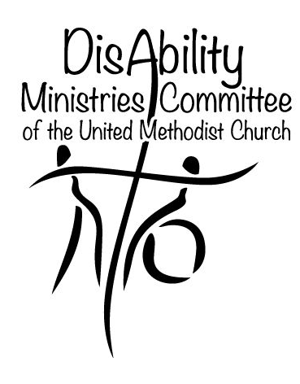
Author’s Guide for UM Disability:
- The VOICE of the United Methodist Disability Connection
- Signs of Change
- UM Disability blog (umdisability.blogspot.com)
- Websites (umdisability.org, umdeaf.org)

We are open to considering articles about disability that are faith-based for our newsletters, websites, and blog.

The VOICE provides practical disability-related information based on experiences of people in local United Methodist churches and agencies. Signs of Change is similar but focused on Deaf and hard-of-hearing information. We also cover churches and conferences in the global autonomous Methodist churches. In general, each issue has a theme with several related articles. We cover topics related to disability and the church, and trends in ministry with people of all ages who have disabilities.

The Voice: We publish the newsletter electronically up to 4 times a year. Articles are due by the 15th of the month when an issue will be published. Contact editor Lynn Swedberg at umdisability@gmail.com for a schedule of topics and dates.
Signs of Change: we publish the newsletter electronically up to 6 times a year. Contact the editor at umdeaf@gmail.com for a schedule of topics and dates.

The Resource sections of the newsletters go beyond the United Methodist church to include books, articles, websites, DVD’s, and other information that can be used by our churches to build ministries with people with disabilities. We promote upcoming disability-related conferences, workshops, and continuing education opportunities. Please submit ideas for resources that support your article.

Newsletter articles are concise so they can be easily read or skimmed by busy people. Longer articles are either edited to shorten them, or divided into two related articles. Please refer to past issues to get a sense of the style we seek: The Voice (http://archive.constantcontact.com/fs017/1104745249463/archive/1105342717839.html) and Signs of Change (http://www.umdeaf.org/news/index.html).

Technical Specifications

Newsletter articles should be 500 words or less.

Blog articles may be somewhat longer. They should reflect individual thoughts on topics of more immediate concern, or insights into technical matters (such as accessibility details). Newsletter articles are often adapted to create reference articles for the websites. We prefer this approach for generating new material for our websites.

Use current people-first standards in your choice of language. Consult online guides such those by the APA (http://www.apastyle.org/manual/related/nonhandicapping-language.aspx) or Disability is Natural (http://www.disabilityisnatural.com/people-first-language.html) for more information.

Color photographs of actual people or features of the program you are describing help make the text come alive. You need to have a photo release for each identifiable person in the photos. Let us know if you are using your own release form or need the Global Ministries form. Please submit photos as an attachment to your e-mail, using a jpg format.

Submit articles to the editor electronically, preferably as a Microsoft Word document. All articles will be edited for content and style, and to conform to any requirements of General Conference of the United Methodist Church.

Please title your article and include your name, address, church affiliation, email, and phone number. Add a short one-sentence byline that tells us who you are, what you do, or how you would otherwise like to be identified as the author of the article.

All materials are submitted gratis, and those accepted become the property of the committee involved.

Lynn Swedberg,
Editor, The VOICE of the United Methodist Disability Connection
Disability Consultant, DisAbility Ministries Committee of the UMC
Leo Yates Jr
Editor, Signs of Change
Consultant, United Methodist Committee on Deaf and Hard-of-Hearing Ministries
Tim Vermande,
Communications Consultant, DMC and DHM

