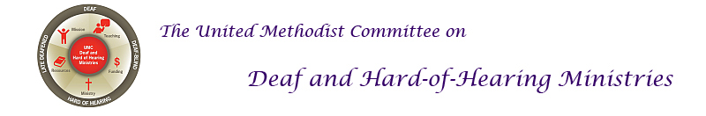

AMERICAN SIGN LANGUAGE
American Sign Language (ASL) is the preferred language for the Deaf community, those who are Deaf, hard of hearing, and Deafblind. When one sees a capital ‘D’ in the word Deaf, it indicates cultural deafness within what is discussed or stated. Besides indicating hearing loss, the lower-case “d” indicates someone who is not culturally deaf. Most Deaf people DO NOT read lips. Learning the manual alphabet can help bridge the communication, at least in a small way.
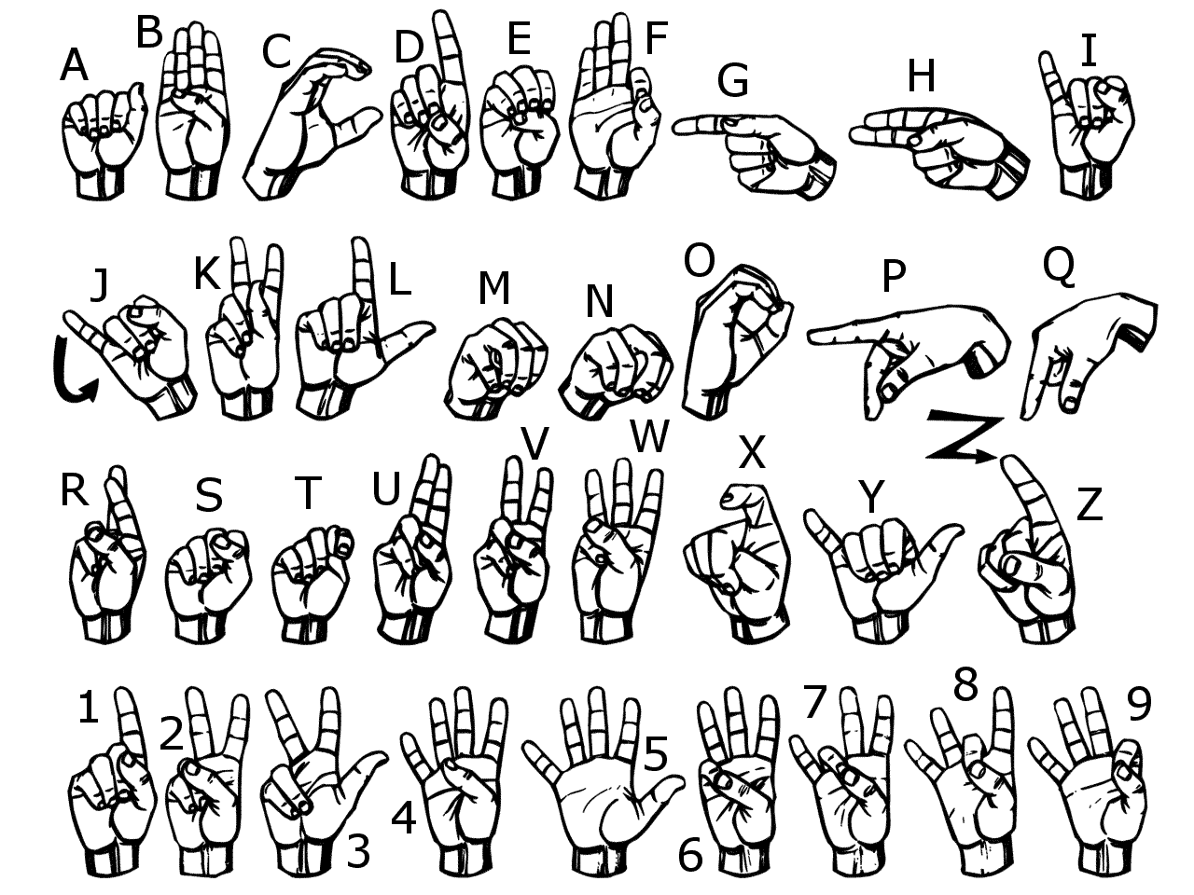
For more information, go to the United Methodist Committee on Deaf and Hard of Hearing Ministries website at www.umdeaf.org.
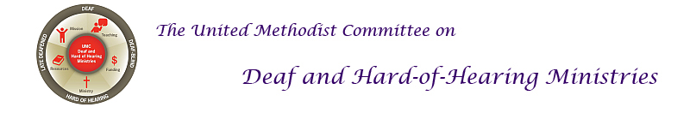
AMERICAN SIGN LANGUAGE
American Sign Language (ASL) is the preferred language for the Deaf community, those who are Deaf, hard of hearing, and Deafblind. When one sees a capital ‘D’ in the word Deaf, it indicates cultural deafness within what is discussed or stated. Besides indicating hearing loss, the lower-case “d” indicates someone who is not culturally deaf. Most Deaf people DO NOT read lips. Learning the manual alphabet can help bridge the communication, at least in a small way.
For more information, go to the United Methodist Committee on Deaf and Hard of Hearing Ministries website at www.umdeaf.org.

