**UNITED METHODIST COMMITTEE ON DEAF AND HARD OF HEARING MINISTRIES**

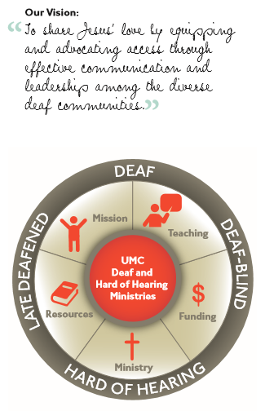

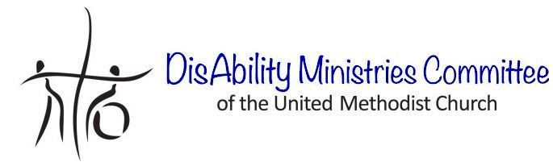

Check out our sister committee,   
DisAbility Ministries Committee   
of The United Methodist Church www.umdisabilityministries.org  
decorative border  
 **Additional Resources**

For additional congregational resources, visit the United Methodist Congress of the Deaf’s website  
at www.umdeaf.org.

A helpful resource is  
*Deaf Ministry: Ministry Models   
for Expanding the Kingdom of   
God, 2nd Ed* by Leo Yates, Jr. It  
can be purchased at Amazon.com.

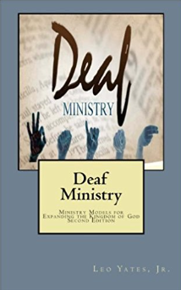

“To share Jesus’ love by equipping and advocating access through effective communication and leadership among the diverse   
Deaf communities.”

**United Methodist Committee on   
Deaf and Hard of Hearing   
Ministries Committee**  
Contact Rev. Leo Yates, Jr. at leoyjr@gmail.com for additional information or for a consultation. Also, contact him to receive our quarterly newsletter. The newsletter includes resources, best practices, national and local Deaf ministry news, and other information.  
www.umdeaf.org

**Guidance for a Deaf-blind Ministry**



**United Methodist Committee on Deaf and Hard of Hearing Ministries**

**Global Ministries**  
The United Methodist Church

**General Board of Global Ministries**

**The United Methodist Church**

**458 Ponce De Leone Ave NE**     
**Atlanta, GA 30308**

**www.umcmission.org**

**United Methodist Committee on Deaf and Hard of Hearing Ministries**  
www.umdeaf.org

**United Methodist Association of Ministers with Disabilities**  
www.umdisabledministers.org

**DisAbility Ministries Committee  
of The** **United Methodist Church**  
www.umdisabilityministries.org

**The United Methodist   
Congress of the Deaf**  
www.umcd.org

**How to Support the Committee  
Give to the Advance:**By Check:  
Make payable to your local church or “Advance GCFA.” Be sure to write Advance #982562 and “Committee on Deaf and Hard of Hearing Ministries” on the check. For local church and annual conference credit, give your gift to your local church treasurer.  
  
By Credit Card:  
Call 1-888-252-6174 or go to www.umcmission.org/Give-to-Mission/Give-to-Mission and search for Advance #980562.

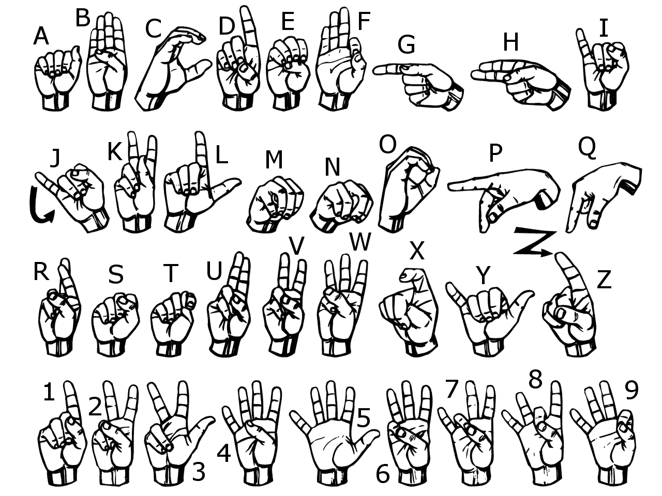

**The United Methodist Committee on   
Deaf and Hard of Hearing Ministries** is a Global Ministries committee. The committee provides resources, consultation, cultivates Deaf ministries, educates congregations, helps to develop Deaf leaders, and offers grants to United Methodist churches. Helpful to know is when reading a capital ‘D’ in the word deaf, it indicates cultural deafness within what is discussed or stated. Besides indicating hearing loss, the small‘d’ in deaf indicates someone who is not culturally Deaf.

**Deaf-Blind People**

The Deaf-blind ministry model focuses on individuals with both a hearing loss and a vision loss, who are frequently missing from the pews, but they too are meant to be part of the church. People with hearing and vision loss need accommodations just like the rest of the Deaf and/or hearing community. The term 'Deaf-blind' can be somewhat misleading. The misconception that a person is fully blind and fully deaf, which is not always the case. Deaf-blind individuals vary in hearing and visual loss, which means there is not one specific method for provision of accommodations.

There are four basic types of Deaf-blindness: (1) Being blind first and deaf later, (2) being deaf first and blind later, (3) being born deaf and blind, and (4) and being suddenly deaf and blind later in life (perhaps from an accident or an illness). These categories tell the world about how the Deaf-blind person will communicate. In general, Deaf-blind people experience problems with communications (having barriers), access to information, and mobility. However, their specific needs vary enormously according to age, onset, their communication modality, and type of vision loss. Most Deaf-blind people do not attend church, making the body of Christ incomplete and not fully represented in our churches.

**Communication Methods**

There are a variety of communication methods used by Deaf-blind people. Some include:

1. Sign language may be used, but in restricted space due to vision loss or with additional light.
2. Adapted sign language may used based on the type of vision loss.
3. Tactile signing is when a Deaf-blind person puts his or her hands over the signer’s hands to feel the shape, movement and location of the signs.
4. Tracking is when the Deaf-blind person follows signs by holding the signer’s forearm or wrist and uses his/her eyes to follow along. This may be needed due to the restricted vision.
5. Communication options such as POP (print on palm), tactile, CV (close vision), distant signing, tracking, limited space/tunnel vision, tactile fingerspelling, sim-com (speaking and signing at the same time) if the person still has some residual hearing.
6. Assistive technology has provided further access to Deaf-blind people through the use of cell phones, iPads, devices, and computers.

More information and resources can be found on the American Association of Deaf-Blind’s website (www.aadb.org).

**Support Service Providers (SSPs)**

Support service providers (SSPs) relay visual and environmental information, act as sighted guides and facilitate communication for people who are Deaf-blind, using the Deaf-blind person's preferred language and communication mode. SSPs enable Deaf-blind persons to access their communities and connect with other people. This can be a ministry all in itself.

**Ministry Considerations**

Ministry considerations for a Deaf-blind ministry include some of the following:

1. Create fellowship opportunities, which includes plans for transportation, volunteers (like ASL students), and hospitality. Consider themed events.
2. Provide transportation to and from church functions if mobility isn’t an option.
3. Offer SSP services or volunteers.
4. Move beyond accessibility and assist the Deaf-blind person(s) in participating in ministry activities.
5. Offer large print materials.
6. Establish a Deaf-blind ministry program that includes outreach to this community.
7. Have Interpreting services for worship and other church activities.
8. Accessibility accommodations (the Deaf-blind person will tell you what is needed, as it varies by the person).
9. Perhaps co-leading a ministry program led by a Deaf-blind person.